**Why Did Sales Drop in April?**

In January Sales began strong at 108,759.60 dollars, indicating a solid start to the year possibly fueled by post-holiday shopping or promotions. But there was a noticeable drop to 93,694.26 dollars in February

In March Sales bounced back impressively to 109,170.11 dollars, surpassing even January sales. But a significant dip occurred with sales dropping sharply to 47,469.04 dollars in April, less than half of March's total. Sales recovered strongly to 109,501.40 dollars in May, the highest monthly figure in the period. In June Sales slightly dipped to 102,643.18 dollars, still a healthy figure relative to earlier months.

April saw a significant decline in both total sales and transaction volume. To uncover the root causes, I examined performance across customer types, product categories, and regions.

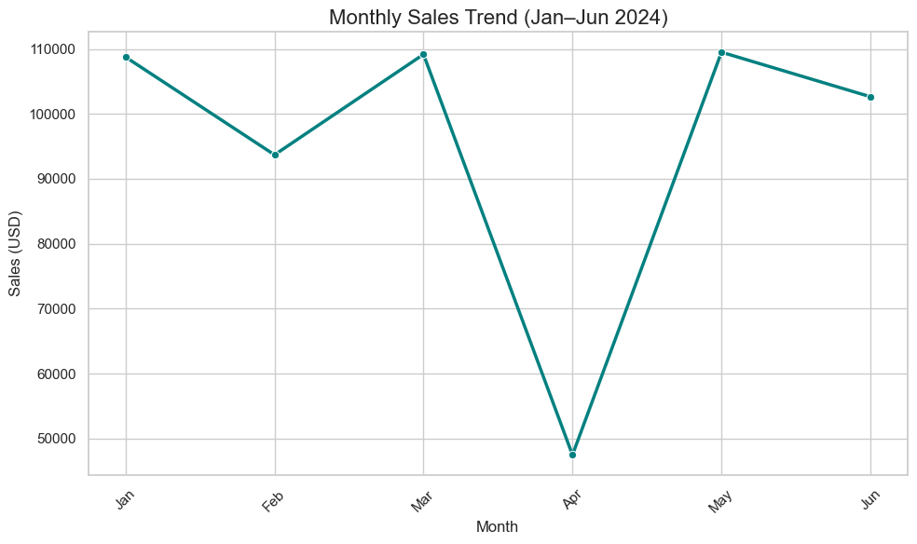

**By Customer Type**

|  |  |  |  |
| --- | --- | --- | --- |
| Customer Type | Units Sold | Sales (USD) | Avg. Discount |
| New | 498 | $13,998.33 | 20.9% |
| Returning | 1161 | $33,470.71 | 19.8% |

Returning customers contributed over 70% of April’s sales, which is expected, but even their numbers were much lower than in other months.

Discounts for both customer types were significantly higher than the overall monthly average, possibly signaling a promotion strategy that didn’t yield strong conversions.

Despite aggressive discounting, both new and returning customers bought fewer products in April. This suggests that external factors (seasonality, lower traffic, etc.) may have impacted shopping activity more than price sensitivity.

**By Category**

|  |  |  |  |
| --- | --- | --- | --- |
| Category | Units Sold | Sales (USD) | Avg. Discount |
| Bodywear | 307 | $10,085.63 | 19.9% |
| Footwear | 331 | $19,616.50 | 20.0% |
| Handwear | 377 | $4,197.56 | 20.3% |
| Headwear | 348 | $4,431.89 | 20.3% |
| Legwear | 296 | $9,137.46 | 19.9% |

All categories offered similar discounts (around 20%), yet sales remained low across the board.

Footwear, which is usually the top performer, still led the month but generated less than half its usual revenue.

No single category underperformed in isolation, the drop was consistent across all product lines, pointing again to a broader dip in demand or engagement.

**By Region**

|  |  |  |  |
| --- | --- | --- | --- |
| Region | Units Sold | Sales (USD) | Avg. Discount |
| East | 417 | $11,626.43 | 19.9% |
| North | 449 | $12,900.98 | 20.5% |
| South | 435 | $12,162.72 | 20.6% |
| West | 358 | $10,778.91 | 19.2% |

Every region saw reduced sales, with West performing the weakest.

Discounts were again higher than usual, but still didn't drive enough conversions.

The sales dip was not isolated to any single region further confirming this was likely due to seasonal factors, an external event, or a dip in traffic/marketing reach rather than product or customer-type issues.

April’s sales drop was broad and systemic:

* Transactions were down across all customer types, categories, and regions.
* Discounts were significantly higher, suggesting an attempt to stimulate demand, but the response was underwhelming.
* This may reflect external market factors, a poorly timed promotion, or perhaps a seasonal lull in demand for clothing items.